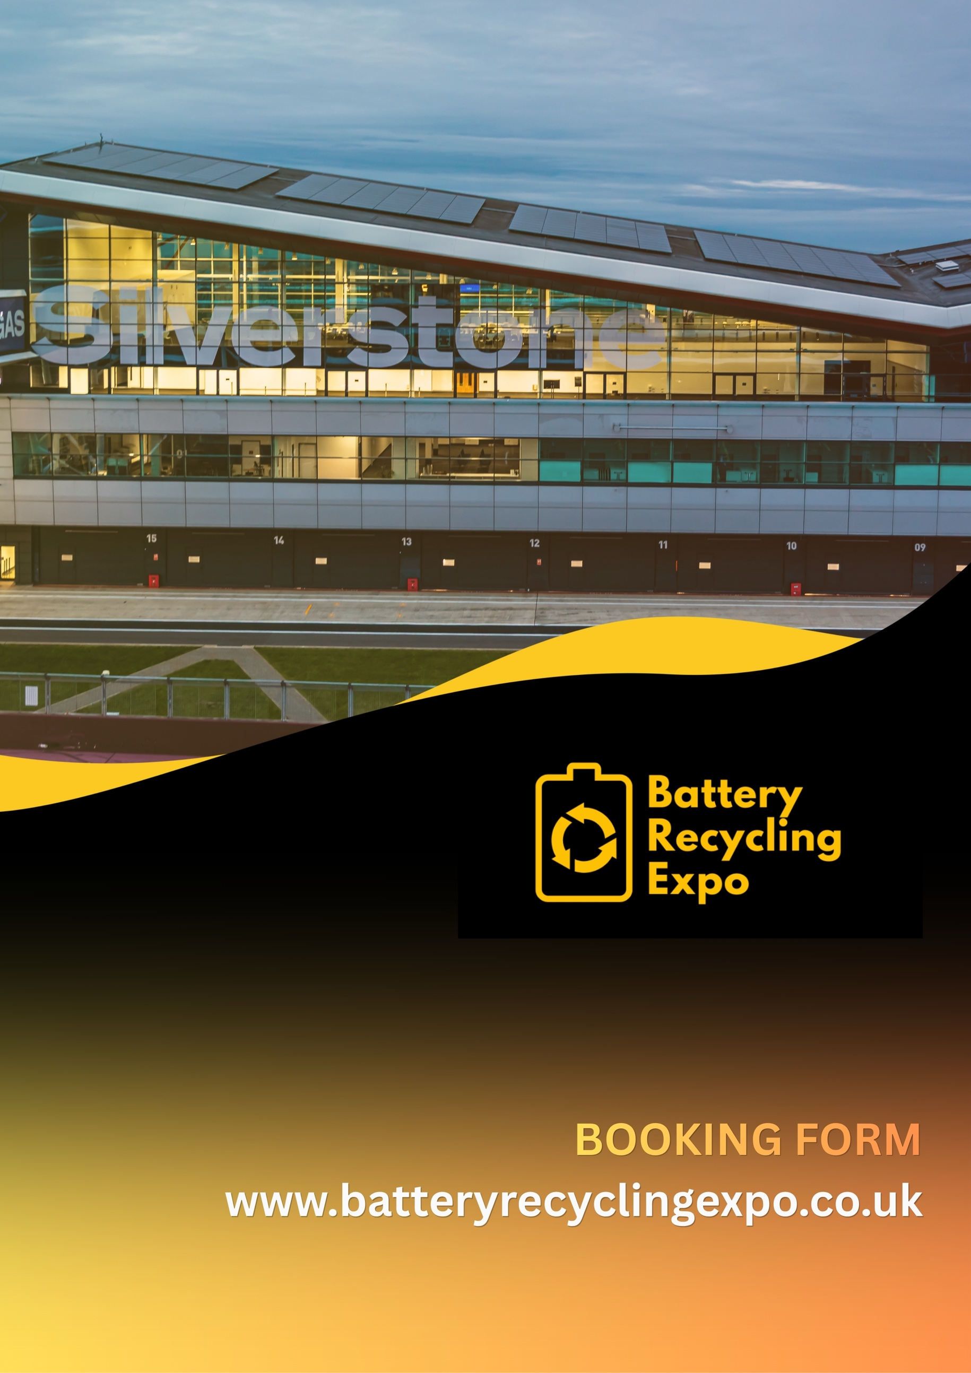

Company Name Address

City

County

Postal Code

Country

Event Contact Email Address Contact Number

Invoice Address

Invoicing Email

Purchase Order (if required)

Sponsorship & Exhibiting Opportunities

Exhibiting Packages

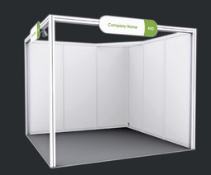
Shell
Scheme Options
3x3m - £2,250 + VAT
6x3m - £4,950 + VAT
The perfect cost-effective solution for exhibiting partners requiring a turn-key option and a range of easy to order, add-on
accessories.

Sponsorship Packages

Includes:
- Shell Scheme
(single 3mx3m or double 6mx3m)
- Name Fascia Board
- Web Exhibitor Directory 100-word listing
- Event Guide 100-word listing

Extra Items Available To Order:
- Power, Spotlights, Furniture, TVs, Graphic Panels

SPACE ONLY STANDS - Please indicate on the booking form is you require space only/will be building your own stand structure

Gold Partner - £9,500 + VAT Platinum Partner - £16,000 + VAT Lectern Sponsor - £2,350 + VAT Lanyard Sponsor - £3,900 + VAT Start-Up Zone Sponsor - £16,000 + VAT Registration Sponsor - £8,750 + VAT Delegate Bag Sponsor - £1,895 + VAT Insert - £495 + VAT

Speaking Opportunities

Brand exposure not only at the event, but before in all communications

includes:
Front Page coverage in weekly communications to 30k
Brand on all event screens & event materials Event guide listing & half page advert
3m x 3m Shell Scheme Exhibition Space

To be part of the 2026 speaker programme, register your interest now by contacting David Reeks at 10Four Media Ltd: david.reeks@104-media.com

Speaker sessions are 20 minutes including a Q&A.

BOOKING OPTIONS

3m x 3m Stand - £2,250 + VAT 3m x 6m Stand - £4,950 + VAT
Presentation Stage Sponsor - £2,350 + VAT Lanyard Sponsor - £3,900 + VAT
Cafe & Networking Zone Sponsor - £8,750 + VAT Welcome Lounge Sponsor - £8,750 + VAT Platinum Partner (includes stand) - £16,000 + VAT Gold Partner (includes stand) - £9,500 + VAT

Please indicate preferred stand number:

Please note stands are allocated by the organisers and cannot be guaranteed. PLEASE MAKE US AWARE OF ANY SPECIFIC REQUIREMENTS INCLUDING
SIZE/WEIGHT OF EXHIBITS - This may impact your stand position Please refer to Terms and Conditions.

CONFIRMATION

By my signature, I acknowledge that I have read, understood and agreed to the Terms and Conditions in this document and agree to pay the invoice within 30 days:

Name Signature

Date

Terms and Conditions

- Should the government restrict gatherings during this period, 10four Media Ltd hold the right to postpone the event and run on a new date when legally allowed to do so. No extra charge will be incurred to exhibitors or sponsors for the new date, but no refunds will be issued.
- The event is wholly owned by 10four Media Ltd, 10four Media Ltd is referred to in this document as 'The Company'.
- A booking can be reserved by contacting The Company. The booking form must be completed and received for the booking to be confirmed.
- All prices exclude VAT at the current rate.
- The full booking fee is payable immediately upon confirmation of the booking.
- In an effort to reduce waste paper, we prefer payments by BACS or other electronic means of payment.
- Failure to comply may result in your booking being cancelled and you being liable for the total cost.
- Cancellations must be made in writing to The Company.
- In the event of a cancellation the following charges will apply:
- From booking form receipt – 50% of total value
- Within 60 days prior to event - 75% of total value
- Within 30 days prior to event - 100% of total value
- In the event of uncontrollable circumstances preventing us from being able to fulfil our contracted obligations our liability shall be limited to a refund of any monies paid in relation to the contracted event or a pro rata reduction in the hire fee in the event of delayed start. No further compensation will be paid irrespective of any loss of earnings.
- Any cheques returned not cleared by our bankers will be subject to a £55.00 charge.
- The Company reserves the right to cancel, alter, or delay any booking where forced to do so by circumstances beyond our control.
- The company reserves the right to substitute hired equipment with equipment of a similar type and value in the event of previous damage or loss of booked equipment.
- The directors of The Company reserve the right to send away any person who in their judgement is found to be unmanageable or a danger to the safety or enjoyment of others. In this event no refund will be given. Any additional costs and responsibility involved in removing the participant will be borne by the client.
- Safety must be paramount, and all participants must accept that the decision of the Company is final and at all times be accepted by the participants. The Company will accept no liability for problems arising from failure to accept and/or respond to the authority and instructions of the appointed staff.
- Any and all photographs, videos, or other recorded media may be used by The Company for the purposes of marketing or advertising without any payment or compensation being offered and without any request being made to the featured parties.
- Equipment, once sited, will not be moved. Ensure that you advise our staff where you want them to setup accurately. The Company will not be liable for damage to equipment at the event
- Any newspaper or other media reports organised by the client or the client representative must be approved with the directors of The Company before publication. Any published reports relating to activities organised by The Company must include the company name and contact details.
- No Liability is accepted for:
- Loss of or damage to property belonging to or travelling with the members of any group. For example watches, jewellery, cameras or clothing
- Losses or additional expenses due to delays or changes in travel services, sickness, weather, strikes, riots, war, quarantine or any other cause.
- Personal injury or death of any participants however caused unless by proven negligence of the company.
- In the event of any damages caused by participants to property or equipment in use by The Company, except by fair wear and tear, the client will be charged the full replacement cost.
- Any damages must be reported to a member of The Company staff immediately.
- If you have any complaint during your booking, please notify the directors of The Company or The Company representative immediately. We will then do our utmost to find a speedy and satisfactory solution. In the event that you are not satisfied with the solution please complain in writing to the managing director of The Company within 14 days of the end of your booking.
- For the comfort, health and safety of all concerned, there will be no smoking during any event.
- Should the government impose a lockdown during this period due to the Coronavirus, 10four Media Ltd hold the right to postpone the event to a new date when legally allowed to do so. No extra charge will be incurred to exhibitors, but no refunds will be issued should exhibitors decide to cancel as a result.

10Four Media Ltd.
10 Stadium Business Court
Millennium Way, Pride Park, Derby, England, DE24 8HP

